
SPECIFICATION

Micro Dynamic Speaker
器

RoHS Compliance & Halogen Free

Product : 17*12*2.35 Speaker
GETTOP P/N: SAS171223PA**
Version : P/0

Designed by | Checked by | Confirmed by |  | Approved by | Released date
Jianfeng Zhang | Zhenyu Shen | Chao Gao | Ethan |  | 2025.5.13
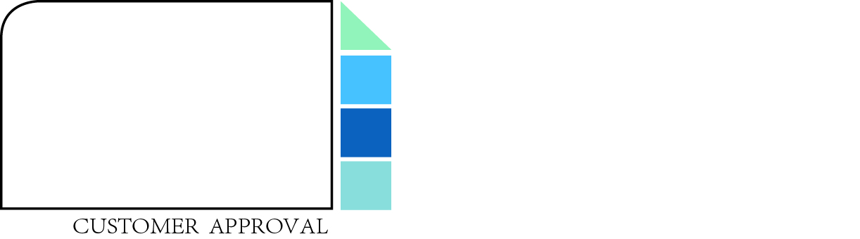
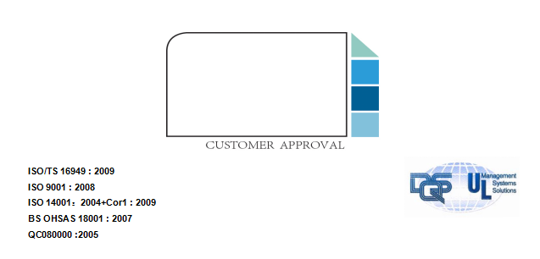
ISO/TS 16949 : 2009
ISO 9001 : 2008
ISO 14001：2004+Cor1 : 2009
BS OHSAS 18001 : 2007
QC080000 :2005

ISO/TS 16949 : 2009
ISO 9001 : 2008
ISO 14001：2004+Cor1 : 2009
BS OHSAS 18001 : 2007
QC080000 :2005

Revision History

Date | Version | Description | Controller
2025-05-13 | P/0 | Initial Release | Jianfeng Zhang

目 录
1. Scope 4
2. Mechanical Layout and Dimensions 4
2.1 Main Dimensions 4
2.2 Appearance drawing 4
3 Electro-Acoustic Characteristics 5
3.1 Typical Electroacoustic Parameters 5
3.2 Frequency Response 6
3.3 THD 7
3.4 HOHD 8

Scope

This specification is the basic technical specification for SAS171223PA** products of Gettop Acoustic Co.,Ltd, the device meets ROHS、REACH and other environmental requirements, the control of hazardous substances meets the requirements of Gettop’s latest of “Environmental Management Material Standard”.

Mechanical Layout and Dimensions

2.1 Main Dimensions
-

+

Remark：
1、“*”Critical Dimension
2、Unmarked tolerance:±0.15mm
3、Dimensions with（）are reference dimension
- Unit：mm

2.2 Appearance drawing
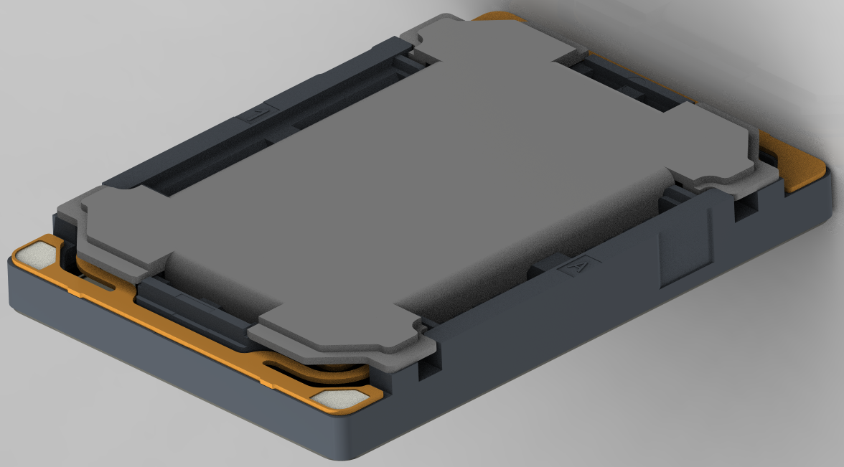
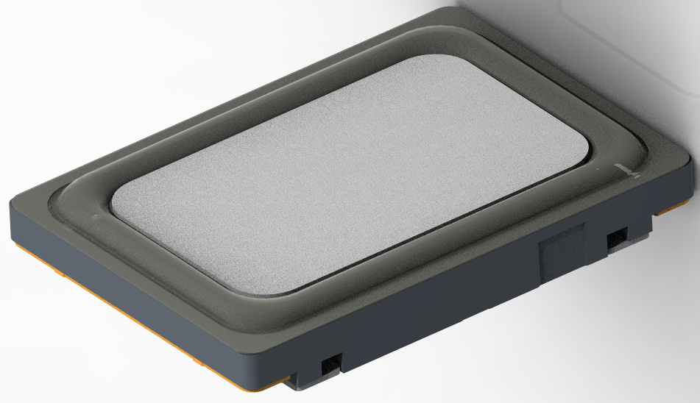

Electro-Acoustic Characteristics

Typical Electroacoustic Parameters
No. | Parameter | Technical Specifications | Unit | Conditions
1 | DC Resistance | 7±10% | Ω
2 | Rated AC Impedance | 8±15% | Ω | @2kHz
3 | Rated Power | 1.7 | W
4 | Maximum Short Time Power | 2.5 | W
5 | Resonance Frequency | 1010±10% | Hz | in 0.8cc back case (measured @1.7W) ,25℃
6 | Sound Pressure Level-1 | 97±3 | dB | @2kHz /3.7V/10cm SC Baffle in 0.8cc back case
7 | Sound Pressure Level-2 | 84+/-3 | dB | @500Hz/3.7V/10cm SC Baffle in 0.8cc back case
8 | Listening condition | No Audible Rub & Buzz |  | 3.7Vrms（1.7W）, in 0.8cc back case  100Hz~2kHz；sine wave ，time：1~2s；2cycles

Frequency Response
Test condition：sine wave, 100～20KHz, 1/12 OCT, 3.7V;0.8cc back case，baffle

FR

FR（Hz） | Upper |  | FR（Hz） | Lower
FR（Hz） | Before Reliability | After Reliability | FR（Hz） | Before Reliability | After Reliability
300 | 78 | 79 | 300 | 72 | 71
500 | 87 | 88 | 500 | 81 | 80
1000 | 105 | 106 | 1000 | 99 | 98
1200 | 105 | 106 | 1200 | 99 | 98
2000 | 100 | 101 | 2000 | 94 | 93
6000 | 99 | 100 | 6000 | 91 | 90
10000 | 99 | 100 | 10000 | 91 | 90
FR Limit

THD
Test condition：sine wave, 100～20KHz, 1/12 OCT, 3.7V;0.8cc back case，baffle

THD

THD（Hz） | Before Reliability | After Reliability
200 | 35 | 45
400 | 35 | 45
1000 | 20 | 26
2000 | 6 | 7
10000 | 6 | 7
THD Limit

HOHD
Test condition：sine wave, 100～20KHz, 1/12 OCT, 3.7V;0.8cc back case，baffle

HOHD

R&B（Hz） | Before Reliability | After Reliability
200 | 1 | 1.5
1200 | 1 | 1.5
2000 | 0.5 | 0.75
HOHD Limit

