FEATURES
▪ Imaging Array
− 100 × 100 Array
− 1/6 Optical Format
− Pixel Pitch: 16.8 µm
− Frame Rate: up to 120 fps
▪ Interface
− Control Interface: CCI(I2C)
− Data Interface: MIPI CSI-2
▪ 3.3V Single Power upply
▪ Low Power onsumption with Scalability − <50mW @ 30fps

APPLICATIONS
▪ 3D Sensing
▪ 3D Face & Gesture Recognition
▪ 3D Gaming and AR/VR Solutions
▪ Security,Surveillance,Industry

GENERAL DESCRIPTION
The OPN8001 Time-of-Fight (ToF) sensor for 3D sensing is one key product of OPNOUS ToF solutions, which offers 100×100 resolution data at frame rates up to 120 frames per second (fps). The device combines ToF sensing with an optimally- designed analog-to-digital converter (ADC) and a versatile, programmable timing generator (TG). OPN8001 is realized upon NIR wave length (850 nm and 940 nm) with an industry leading accuracy. The power consumption of OPN8001 achieves the lowest level in the industry, which will benefit many portable and energy saving applications. The device supports MIPI CSI-2 interface.

▪ Leading Accuracy in the Industry
− ≤ 1% of Distance (0.15m ～5m @ 30fps)
▪ On-chip Timing Generator
▪ One System Clock for All Range
Measurement with Wide Range Flexibility
▪ Multi-sensor Capability
▪ Micro Lens Availability with Advanced Optical System Solution Capability
▪ Operating Temperature: -20℃ ~ 60℃

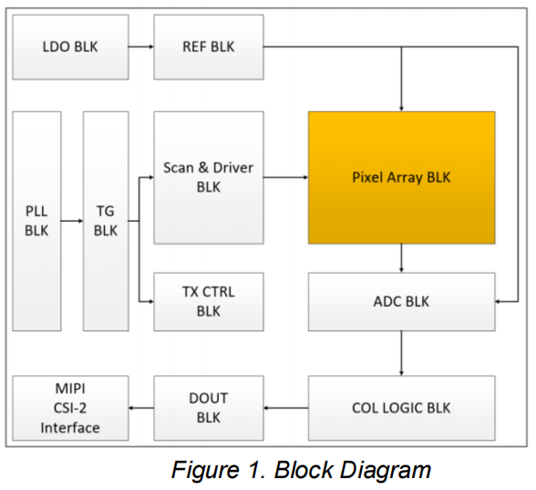
▪ Security,Surveillance,Industry Automation
▪ Drone, AGV and Robot Sensing
▪ Automotive Self-driving Sensing

