General Description
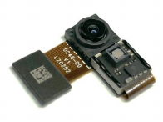
OPNM8501B is a tiny 3D camera module, based on OPNOUS Time-of-Flight (ToF) technology using VCSEL illumination. The high integration, low power consumption and high precision make this module ideal for depth sensing applications.

Key Specifications

Parameter | Description
Sensor | OPN8001D, global shutter
Resolution | 100 * 100
Pixel size | 15um
Sensor size | 1/6’’
Dimensions | 15.00mm * 7.30mm * 3.93mm
Frame rate | Up to 60fps
Measurement range | Up to 1 0 m
FOV | 48°(H) * 48°(V)
Distortion | <2.5%
Illumination | 940nm, 3W
Input clock | 27Mhz
Power supply | Sensor: 3.3V single power supply, >=300mA  VCSEL: 4.6V, >= 1A
Power consumption | 300mW. Typ @ 15fps
Depth accuracy | <= 1% / <=1cm
Interface | MIPI CSI-2, 2 lanes

1

Typical Applications

Face recognition and face motion tracking
3D reconstruction
AR/VR
Hand and finger tracking for gesture control and interaction with virtual objects
Visual support for robot grippers
Localization, tracking and identification of individuals (humans, animals)
People counting and motion analysis

Module Dimensions
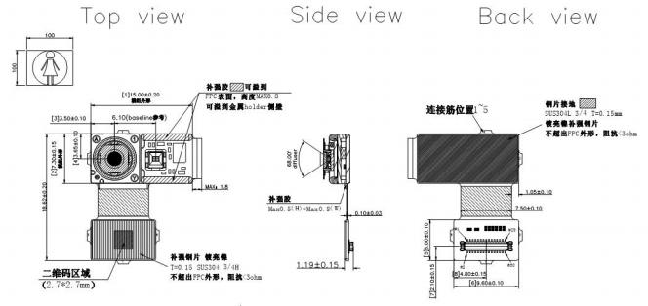
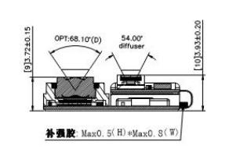

Module connector shown in above Figure:
Part Number of module connector is AXE630124.
Mating connector is AXE530127.

Pin Definitions

Pin No. | Name | Description
1 | AVDD_3V3 | 3.3V Power Supply
2 | VCSEL_4V6 | VCSEL Supply
3 | AVDD_3V3 | 3.3V Power Supply
4 | VCSEL_4V6 | VCSEL Supply
5 | DV33 | 3.3V Power Supply
6 | VCSEL_4V6 | VCSEL Supply
7 | SLV_LSB | Address Select
8 | GND | Ground
9 | GND | Ground
10 | SPI_MOSI | SPI Data In
11 | MCLK | Reference Clock,27MHz
12 | SPI_MISO | SPI Data Out
13 | GND | Ground
14 | SPI_SCLK | SPI Clock
15 | CSI_D0_P | CSI-2 non-inverting data output of data lane 0
16 | SPI_nCS | SPI CS
17 | CSI_D0_N | CSI-2 inverting data output of data lane 0
18 | GND | Ground
19 | GND | Ground
20 | SYNC_IN | Sync input
21 | CSI_CLK_P | CSI-2 non-inverting clock output
22 | ERR | Error indicator
23 | CSI_CLK_N | CSI-2 inverting clock output
24 | I2C_SCL | CCI, Camera control interface
25 | GND | Ground
26 | I2C_SDA | CCI, Camera control interface
27 | CSI_D1_P | CSI-2 non-inverting data output of data lane 1
28 | GND | Ground
29 | CSI_D1_N | CSI-2 inverting data output of data lane 1
30 | RESET_N | Reset (active low)

